sStock
High Level Design

Date | July 20, 2011
Version | 2.0
Status | Pending
Author | [Trinh Duc Tam, Developer]
Reviewed by | Nguyen Thi Thanh Thuy, Project Manager
Approved by | Nguyen Thi Thanh Thuy, Director

Revision History

Date | Version | Description | Author
July 20th, 2011 | 1.0 | <Khởi tạo> | <Trinh Duc Tam>
August 2, 2011 | 2.1 | Re-structure Soft Architecture  Re-structure Sub System Architecture | Nguyen Thi Thanh Thuy

Table of Contents
1 Introduction 4
1.1 Purpose 4
1.2 Scope 4
1.3 Definitions, Acronyms and Abbreviations 4
1.4 References 4
1.5 Overview 4
2 Overview 5
2.1 Design consideration 5
2.1.1 Objectives 5
2.1.2 Hardware specification 5
2.1.3 Software specification 5
3 System Architecture 6
4 Software Architecture 7
4.1 Software Architecture 7
4.2 Module descriptions 8
4.2.1 Module 1 8
4.2.2 Module 2 8
5 Some special case 9

Introduction

Purpose

[This section describes the architecturally significant parts of the design model, such as its decomposition into subsystems and packages, for each significant package, its decomposition into classes and class utilities. You should introduce architecturally significant classes and describe their responsibilities, as well as a few very important relationships, operations, and attributes.]

[For each significant package, include a subsection with its name, its brief description, and a diagram with all significant classes and packages contained within the package.]

Tài liệu này mô tả kiến trúc hệ thống sStock.

Scope

- Tài liệu này mô phỏng mô hình kiến trúc hệ thống và kiến trúc phần mềm của dự án sStock.
- Tài liệu này dành cho tất cả các nhân viên phân tích và phát triển dự án sStock.
- Tài liệu này không dùng cho khách hàng.

Definitions, Acronyms and Abbreviations

No | Term | Description
1
2
3
4
5
6
7
8

References

<List any other documents or Web addresses to which this SRS refers. These may include user interface style guides, contracts, standards, system requirements specifications, use case documents, or a vision and scope document. Provide enough information so that the reader could access a copy of each reference, including title, author, version number, date, and source or location.>

Overview

Overview

Design consideration

Objectives

[This section describes many of the issues which need to be addressed or resolved before attempting to devise a complete design solution]

Hardware specification

[List hardware requirements (Get form Project Requirements Document)]

Table 1: Quy cách về phần cứng

STT | Phần cứng | Quy cách
1 | PC | CPU:Pentium IV 1.4Ghz trở lên.  Bộ nhớ: 512MB hoặc hơn  Màn hình: 1024×768 hoặc hơn  Bàn phím: Connection  Chuột: Connection
2 | ...

Software specification

Table 2: Quy cách phần mềm

STT |  | Phần mềm | Quy cách
1 |  | Hệ điều hành | Windows2000 SP4 and XP SP2
2 |  | MS Office Word 2007 | Phần mềm soạn thảo văn bản
3 | Enterprise Architect 7.0 |  | Phần mềm thiết kế mô hình
4 | SmartDraw 2010 |  | Phần mềm thiết kế mô hình kiến trúc hệ thống

System Architecture



Figure 1: Stock at Outlet - System Architecture

Software Architecture

Software Architecture

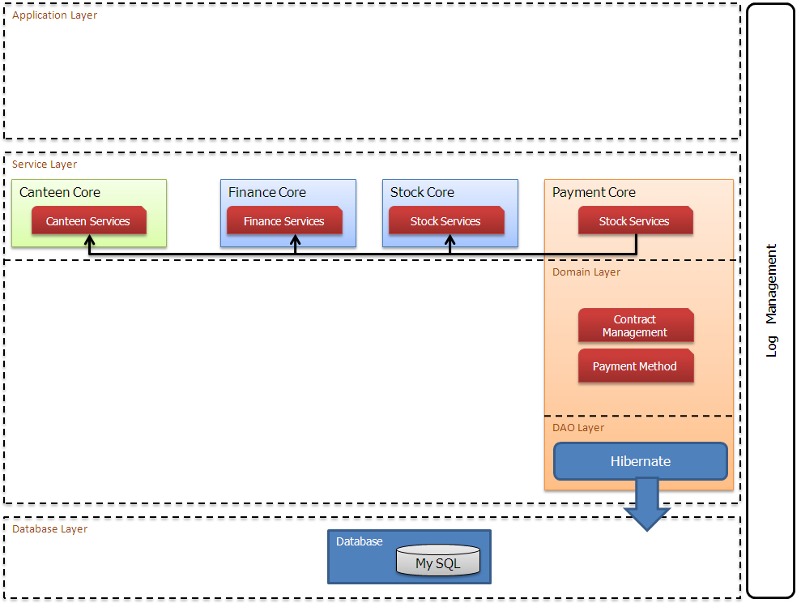

Module descriptions

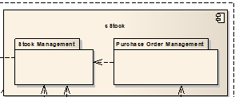

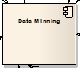

Module 1

The Module1 provides the following packages:

- Package 1:

- Package 2:

Module 2

The Module 1 provides the following packages:

- Package 1:

- Package 2:

Some special case

